Chapter 5, Solution 90.

The op amp circuit in Fig. 5.107 is a current amplifier. Find the current gain i_{o}/i_{s} of the amplifier.

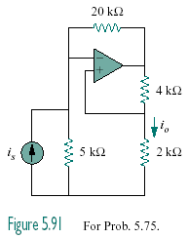

Figure 5.107
For Prob. 5.90.

Solution

Transforming the current source to a voltage source produces the circuit below,

At node b, v_{b} = (2/(2 + 4))v_{o} = v_{o}/3

4 kΩ

5i_{s}

+
−

20 kΩ

+

v_{o}

−
−
+

5 kΩ

2 kΩ

a

b

i_{o}

At node a, (5i_{s} – v_{a})/5 = (v_{a} – v_{o})/20

But v_{a} = v_{b} = v_{o}/3. 20i_{s} – (4/3)v_{o} = (1/3)v_{o} – v_{o}, or i_{s} = v_{o}/30

i_{o} = [(2/(2 + 4))/2]v_{o} = v_{o}/6

i_{o}/i_{s} = (v_{o}/6)/(v_{o}/30) = 5

